Screenshot1

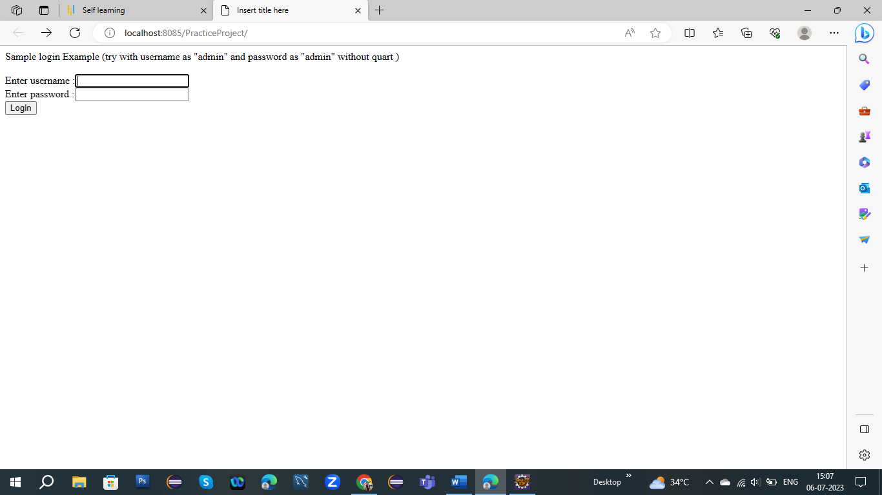

Screenshot2:-

Here I put valid username and password

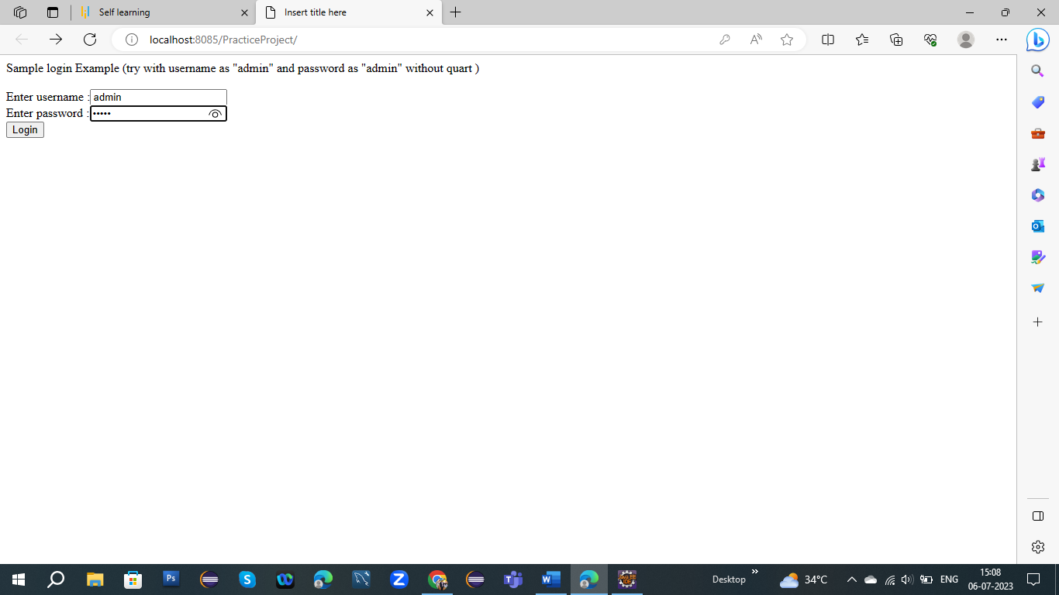

Screenshot3

Here I got login success output

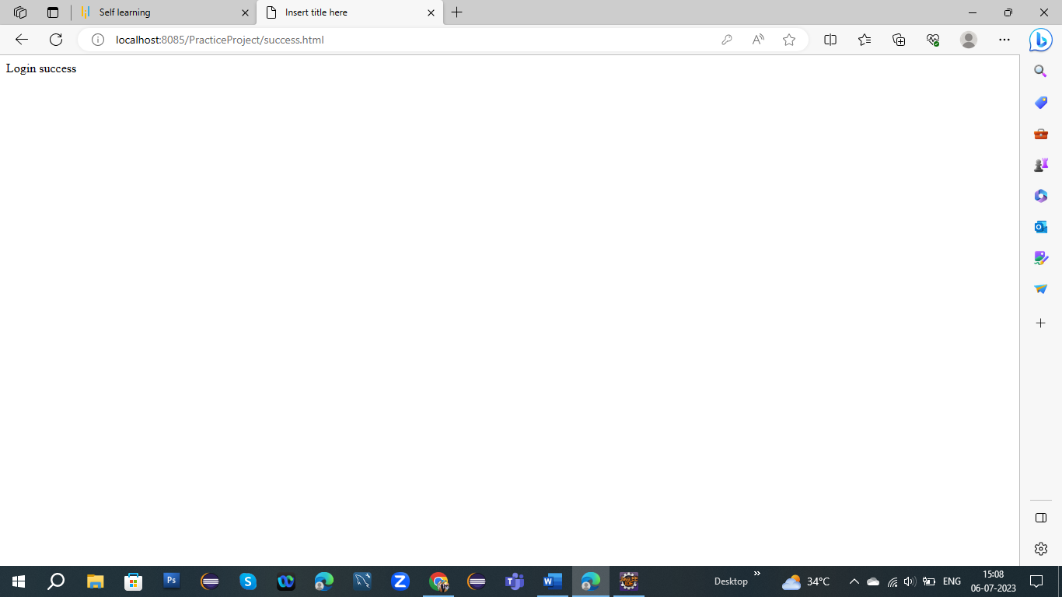

Screenshot4:-

Here I put the invalid username and password;



Screenshot5:-

Here I got output login fail;

